

DEPARTMENT OF ELECTRICAL AND ELECTRONIC ENGINEERING (EEE)

OPTION: ELECTRICAL TECHOLOGY

MODILE TITLE: PROGRAMABLE ICs WORK SHOP

YEAR OF STUDY: YEAR III

SEMESTOR ONE

NAME OF MIN PROJECT TOPIC: TURNING ON FAN ACCORDING THE TEMPERATURE READING

**PRESENTED BY:**

**NAME: REG:**

**NIYODUSABA Jean Bosco 19RP07752**

**IZABAYO Honore 19RP01569**

**SUPERVOISOR: ISHIMWE Viviane**

**0n 24thapply2022**

**ABSTRACT**

This project is aimed to“turning on fan according to the temperature reading” is based on a AT mega328 microcontroller and temperature sensor called LM 35 this sensor is a precision temperature sensor whose output is linear proportionalto Celsius temperature. the LM35 is rated to operate from -550centigrad to 1500 centigrade with a linear scale factor of +10mv/0c.Therefore when the temperature sensor, sense temperature above or equal to 500 automatically it turns on dc fan to give same air in the room, in the previous years the fan was controlled by using a hands so this project is improved by turning on fan according to the temperature readings with dc fan powered12v and applied where dc fan prevent electromagnetic interference for example, computer application on dc fans, to prevent overheating.[1]

**PROBLEM STATEMENT**

Most of people is difficult to working up during in the dry season with high temperature like studying in the class room or when you sitting in the meeting it disturb/challenge to your activities and the monitoring of the temperature in the room or other place that take heat It was very difficult but my project is recommended to turning on fan according to the temperature detected and it will be easy to monitor the fan for giving the air where there is high temperature.[2]

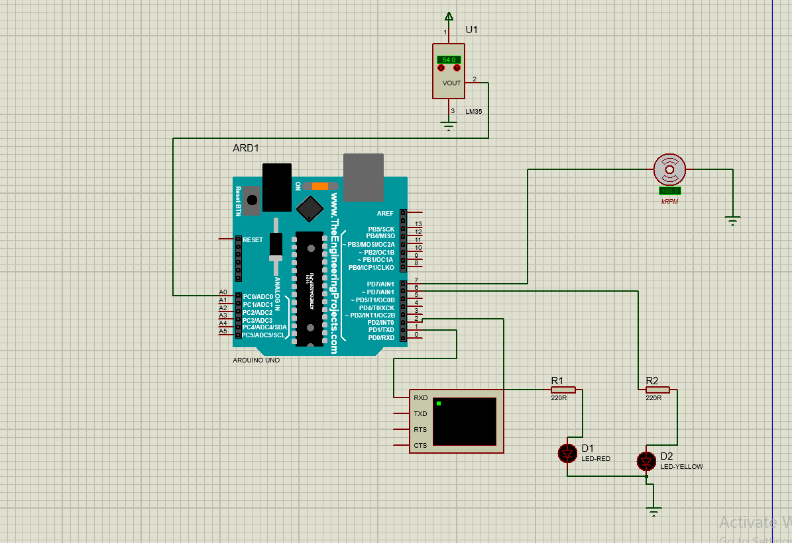

inttemppin=A0;

int fan=7;

inttempvalue=0;

intredled=2;

intyellowled=6;

void setup(){

pinMode(7,OUTPUT);

pinMode(temppin,INPUT);

pinMode(2,OUTPUT);

pinMode(6,OUTPUT);

Serial.begin(9600);

}

void loop(){

tempvalue=analogRead(temppin);

floattempcel= (tempvalue/1024.0)*500;

floattempfarh= (tempcel*9)/5 + 32;

if (tempcel>=50)

{

Serial.println("HIGH TEMPERATURE");

Serial.println ("FAN IS ON ");

digitalWrite(2,HIGH);

digitalWrite(6,LOW);

digitalWrite(7,HIGH);

delay(1000);

}

else {

Serial.println ("LOW TEMPERATURE ");

Serial.println ("FAN IS OFF ");

digitalWrite (2,LOW);

digitalWrite(6,HIGH);

digitalWrite(7,LOW);

}

}

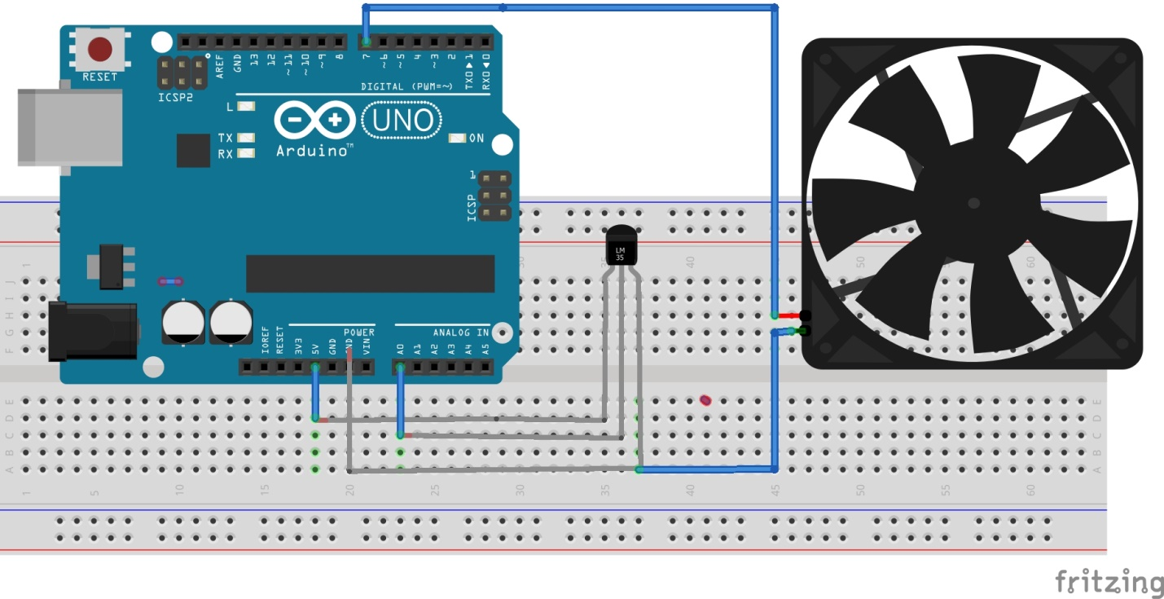

**Block diagram**

Temperature sensor

Arduino uno

**Diagram description**

The LM35 temperature sensor will be used to detect a temperature when it reaches above or equal 500c automatically the red led will indicate if there is high temperature and hence the Arduino will receive the signal from the sensor and will it turning on a dc fan with the yellow led to indicate that the fan is ON and the temperature is below 500C the fan will be OFF.[3]

**REFERENCE**

[1] R. Ali and I. Technology, “Design and development automatic fan,” vol. 8, no. 2, pp. 372–376, 2018.

[2] I. Engineering, “TEMPERATURE BASED FAN SPEED CONTROLLER,” no. November 2017.

[3] E. Of and E. A. Fan, “D EVELOPMENT OF A RDUINO BASED CONTROL SYSTEM USING PIR AND LM 35 SENSOR,” vol. 6, no. 8, pp. 378–389, 2018.